RockPi:
https://wiki.radxa.com/RockpiN10/hardware/gpio

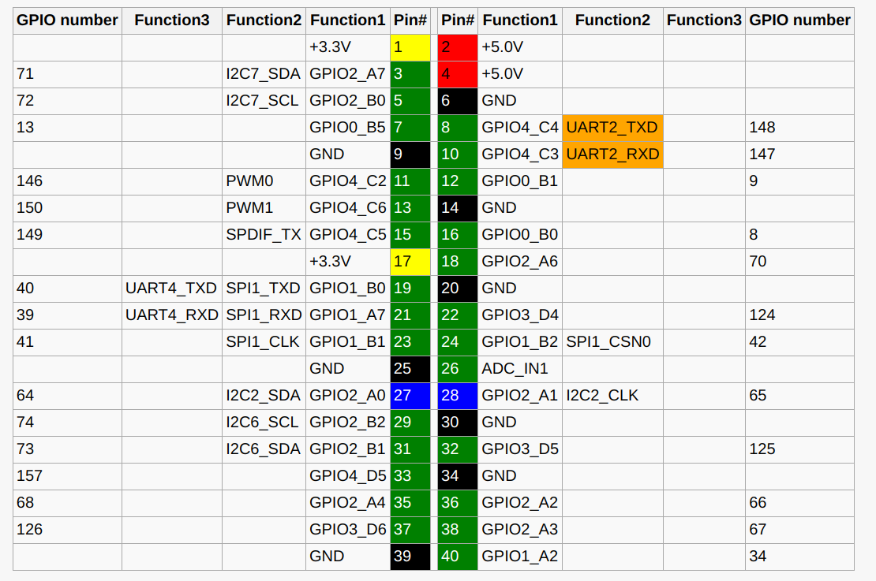
Khadas Pins:
https://docs.khadas.com/linux/vim3/GpioIRQ.html
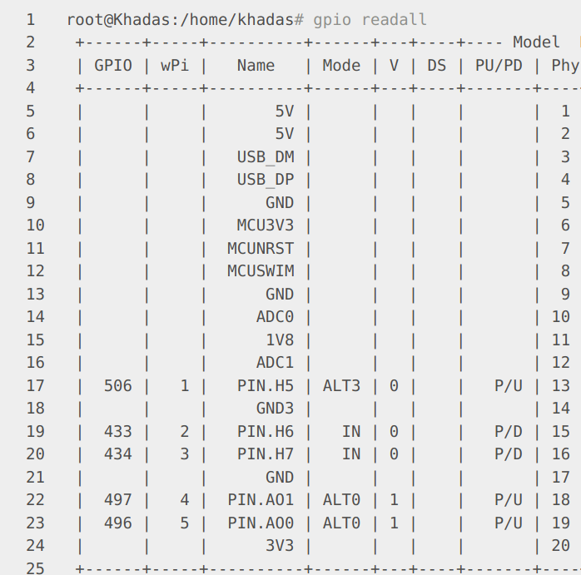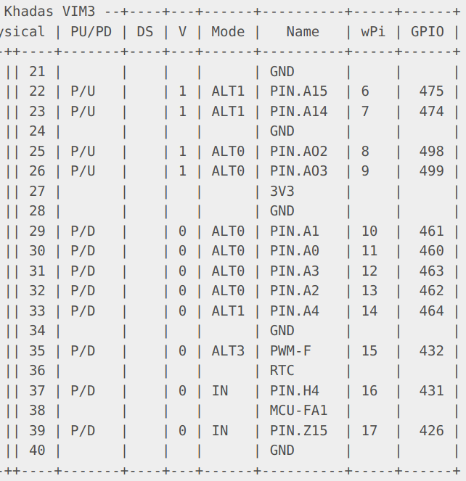

https://docs.khadas.com/android/vim3/AccessGpio.html
Pin 35:
echo 432 > /sys/class/gpio/export
pin 5 is ground

raspberry:
vdd(3.3) -
SDA -
SCL GNd
- -
- -
- PIN18

https://elinux.org/RPi_GPIO_Code_Samples#Direct_register_access

